**IOT - REAL-TIME RIVER WATER QUALITY MONITORING AND CONTROL SYSTEM**

ASSIGNMENT - 3

|  |  |
| --- | --- |
| **NAME** | **Gayathri M** |
| **Reg.NO** | **710419106009** |
| **Assignment** | **3** |

# Write a python code for blinking LED and Traffic Lights for Raspberry Pi.

1. **Python Code for Blinking LED:**

#import RPi.GPIO as GPIO #from gpiozero import LED from time import sleep #led = LED(17)

while True: #led.on()

print("LED turned ON") sleep(1)

#led.off()

print("LED turned OFF") sleep(1)

# Editor Window:

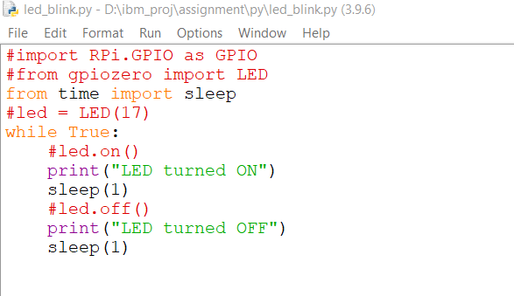

**Output Window:**

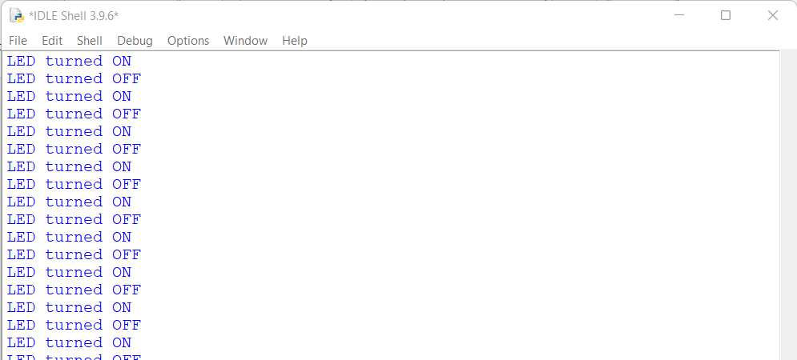

# Python Code for Traffic Lights:

import RPi.GPIO as GPIO import time

import signal import sys #setup

GPIO.setmode(GPIO.BCM) GPIO.setup(9, GPIO.OUT) GPIO.setup(10, GPIO.OUT) GPIO.setup(11, GPIO.OUT)

#Turn off all lights

def allLightOff(signal, frame): GPIO.output(9,False) GPIO.output(10,False) GPIO.output(11,False) GPIO.cleanup()

sys.exit(0) signal.signal(signal.SIGINT, allLightsOff) #Forever Loop

while True: #Red

GPIO.output(9, True) time.sleep(3) GPIO.output(10, True) time.sleep(1)

#Green GPIO.output(9,False) GPIO.output(10,False) GPIO.output(11,True) time.sleep(5)

#Amber GPIO.output(11,False) GPIO.output(10,True) time.sleep(2)

#Amber off GPIO.output(10,False)

# Editor Window:

